DESIGN AND EVALUATION OF GAME-BASED ADAPTIVE SYSTEMS FOR SCHOOL BULLYING INTERVENTION
Author name¹, Author Name ², Author name³, Author Name ⁴
¹Dept. name of organization, name of organization, City, Country
e-mail address
²Dept. name of organization, name of organization, City, Country
e-mail address
³Dept. name of organization, name of organization, City, Country
e-mail address
⁴Dept. name of organization, name of organization, City, Country
e-mail address

Abstract: Bystander Choice – An Adaptive Game System for School Violence Intervention is an interactive role-playing game designed to assess and develop students’ situational decision-making skills in the role of a bystander. The game employs a branching scenario system to track players’ choices and implicitly assess psychological indicators such as empathy and self-confidence. The scenarios are capable of real-time data analysis, enabling the system to automatically adapt the difficulty level and content of subsequent communication scenarios to each individual’s conflict-resolution abilities. An intuitive interface allows students to experience realistic and safe simulated environments in which they can practice decision-making. The tool is intended to support teachers and researchers in collecting behavioral data, including response latency and choice patterns, which can serve as a basis for evaluating the effectiveness of psychoeducational interventions. Ultimately, the system aims to enhance students’ social-emotional skills and contribute to reducing school violence.
Keywords: school bullying, bystander, adaptive game, serious game, visual novel, behavioral data, empathy, self-efficacy, intervention.

Introduction

Research Background and Problem
School bullying is a significant concern in education, as it can negatively affect students’ psychological well-being, academic performance, and ability to integrate socially. Bullying occurs not only in physical forms but also through insults, threats, social exclusion, the spread of negative information, and cyberbullying. In these situations, in addition to the victim and the perpetrator, bystanders play an important role, as their responses can either help mitigate or exacerbate the situation. Behaviors such as intervening, seeking help, supporting the victim, or remaining passive reflect different ways of responding to bullying situations.
Traditional educational approaches can provide students with knowledge about bullying prevention; however, they are limited in their ability to provide opportunities for students to practice decision-making in specific and realistic situations. Educational games, in contrast, offer the potential to construct simulated scenarios in which students can actively engage in such situations. Nevertheless, many existing educational games rely on fixed content and predetermined difficulty levels, which may not adequately account for individual differences in psychological factors and behavioral tendencies.
To address these limitations, this study proposes Bystander Choice, an interactive Visual Novel system designed to simulate school bullying situations and support the development of students’ behavioral and decision-making skills in the role of a bystander. The system employs an adaptive branching mechanism to dynamically adjust subsequent scenarios based on players’ choices and behavioral patterns. This approach aims to provide a more personalized interactive experience that better reflects the characteristics and behavioral tendencies of individual players.

Research Objectives
The overall objective of this study is to design and evaluate an adaptive game system capable of supporting students in developing appropriate behavioral responses to school bullying situations while collecting behavioral data for educational evaluation and research purposes.
To achieve this overall objective, the study focuses on the following specific objectives:
- Design an interactive role-playing game system, Bystander Choice, in the form of a Visual Novel that simulates school bullying situations within a safe and interactive environment.
- Develop an adaptive choice and branching system that allows the content and difficulty level of subsequent scenarios to be dynamically adjusted based on the behavior and choices of individual players.
- Develop a model for assessing players’ behavioral tendencies and evaluate the applicability of the system in supporting situational response skills, as well as providing feedback to learners, teachers, and researchers.

Key Contributions to This Study
- An Adaptive Visual Novel Engine for Bystander Intervention: We present a novel game-based system that transitions beyond static branching narratives by executing real-time difficulty and content adaptation anchored in psychological indicator tracking.
- Fine-Grained Telemetry Framework: We introduce an implicit behavioral logging mechanism that combines decision latency with action appropriateness scores to continuously monitor hesitation reduction.
- Experimental Validation: We provide empirical evidence through an RCT benchmark demonstrating significant immediate gains in bystander efficacy, empathy, and intervention intent compared to traditional educational tools.

Research Subjects and Scope

Research Subjects
The primary research subject of this study is a scenario-based adaptive game system, with a focus on its ability to support students in responding to school bullying situations from the perspective of a bystander.
In addition, the study examines players’ decision-making behaviors during their interaction with the game. The observed behavioral indicators include the selected response options, intervention tendencies, and changes in choices when the severity or content of a scenario is varied.

Scope
The study focuses on school bullying or conflict situations in which the player assumes the role of a bystander. These situations are presented in the form of dialogue-based scenarios and interactive choices, where each choice may lead to different developments in the storyline.
Within the scope of this study, indicators such as empathy, self-confidence, and intervention tendency are treated as behavioral and psychological indicators inferred from the interaction process, rather than as clinical psychological measurements. Accurate assessment of these psychological constructs requires further validation using standardized psychometric scales in future studies.

Related Work
While recent studies, such as the four-wave controlled time-series evaluation of interactive visual novels by [1], have demonstrated the potential of dialogue-based story-driven interventions for bullying bystanders, Bystander Choice advances this paradigm in three key operational dimensions:
- Dynamic Real-Time Adaptation vs. Static Branching: Unlike [1] which relies on predetermined decision trees, our architecture implements a closed-loop adaptive engine $g(E, SE, I, D)$ that dynamically recalibrates scenario difficulty ($D_{t}$) based on continuous state vectors ($ΔS_{t}= {\left[ΔE, ΔSE, ΔI\right]}^{T}$).
- Implicit Telemetry-Driven Assessment: Beyond discrete choice recording, Bystander Choice captures micro-behavioral telemetry, specifically decision latency ($T_{lat}$) and contextual Action Scores ($S_{act}$), allowing non-obtrusive estimation of bystander hesitation and confidence.
- Methodological Focus: While Ref1 examined multi-wave longitudinal adoption patterns, this study isolates the immediate post-intervention efficacy and usability of real-time personalized adaptation via a randomized controlled benchmark (N = 60).
Table 1: Comparative Matrix Between Bystander Choice and Existing Bullying Intervention Serious Games
Study / System | Game Format | Behavioral Telemetry | Study Design & Sample Size | Effect Size (Cohen's $d$)
DeSmet et al. (2016) | Serious Game | Self-report only | Design framework (No RCT) | N/A
Friendly Attac (2018) | 3D Digital Game | Basic choice logging | Cluster-RCT (N = 1,519) | d = 0.32 - 0.45 (Small-Medium)
Kolić-Vehovec et al. (2020) | 2D Scenario Game | Pre/Post survey | Quasi-experimental (N = 214) | d = 0.41 (Medium)
GATE-BULL (2025) | Interactive Module | Survey based | Non-randomized (N = 186) | d = 0.52 (Medium)
Time-Series Study (2026) | Visual Novel | Response time | Controlled Time-Series (N = 45) | d = 0.78 (Medium-Large)
Bystander Choice (This Study) | Interactive Visual Novel | Continuous Telemetry ($T_{lat}, S_{act}, APL$) | Randomized Controlled Trial (N = 60) | d > 2.0 (Immediate Gain)

Theoretical Overview

School bullying and the role of bystanders

Concept of School Bullying
School bullying is a form of repeated aggressive behavior characterized by an imbalance of power between the perpetrator and the victim. It can take various forms, including physical, verbal, relational, and online behaviors. A key distinction between bullying and ordinary conflict is that victims are typically in a disadvantaged position and may have difficulty defending themselves or terminating the situation.
Bullying intervention should not focus solely on perpetrators and victims but should also consider the role of bystanders. Bystanders are individuals who may directly witness, hear about, or otherwise become aware of a bullying incident occurring in a classroom, peer group, or social media environment. Their responses, ranging from intervention and help-seeking to inaction, can influence the development of the incident as well as the surrounding social environment of the victim.

Role of Bystanders
In bullying research, the term bystander refers to an individual who witnesses or becomes aware of a bullying situation without directly assuming the role of either the perpetrator or the victim. Bystanders may respond to such situations in different ways [1].
From an intervention perspective, bystander responses can be broadly categorized into three main groups, which are adopted in this study [2]:
- Passive Response: witnessing the situation without taking meaningful supportive action.
- Indirect Intervention: seeking assistance from teachers or other adults or providing support to the victim after the incident.
- Direct Intervention: actively using appropriate verbal or behavioral responses to stop or reduce bullying behavior.
This classification provides a foundation for Bystander Choice to design in-game response options and analyze players’ behavioral tendencies.

Adaptive Systems and Adaptive Logic

Concept of Adaptive Systems
An adaptive system is a system capable of adjusting its content, difficulty level, or interaction mechanisms based on information collected from the user.
In traditional educational systems, the same content is often delivered to all learners. In contrast, adaptive systems attempt to identify the characteristics or current state of individual learners to provide more appropriate content and learning experiences.
In educational games, adaptability can be implemented by modifying various aspects of the experience, including:
- The complexity of the scenario;
- The difficulty of the decision-making task;
- The type of scenario presented;
- The number of available choices;
- The level of support or guidance provided;
- The feedback provided after each decision.

Adaptive Logic in Bystander Choice
In Bystander Choice, adaptive logic is used to establish a relationship between the player’s current behavior and subsequent scenarios. A generalized model can be represented as follows:
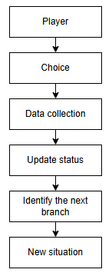
Fig 1. Generalized adaptive model

Each player choice is recorded by the system as behavioral data. These data can be used to update state variables, such as intervention tendency, inferred empathy level, or confidence in handling a given situation. Conversely, if a player consistently selects appropriate intervention strategies, the system may increase the complexity of subsequent scenarios.
Thus, adaptability is not intended solely to create different gameplay experiences across individuals, but also to provide a personalized training pathway that corresponds to each player’s observed behavioral patterns.

Psychological Factors Related to Bystander Behavior

Empathy
Empathy refers to the ability to recognize, understand, and respond appropriately to the emotional states or circumstances of others. In the context of school bullying, empathy plays an important role because the ability to recognize and understand the victim’s emotional state may influence an individual’s motivation to provide support [5].
In Bystander Choice, empathy is not treated as a variable that can be accurately determined from a single choice. Instead, the system may use a combination of behavioral indicators to infer the player’s tendency toward empathic responses.

Self-Efficacy
Self-efficacy refers to an individual’s belief in their ability to perform an action or achieve a desired outcome in a specific situation [6].
Within the game, confidence may be indirectly observed through behaviors such as:
- The ability to select an appropriate intervention strategy;
- The tendency to avoid action in high-pressure situations;
- The time required to decide;
- Changes in choices as the difficulty level increases.

Intervention Tendency
Unlike the two factors described above, intervention tendency is primarily considered a behavioral characteristic of bystander responses. It reflects whether a bystander acts in response to a bullying situation and the way the intervention is carried out [7].
In this study, intervention tendency is categorized into three main groups:
- Passive Response: The player does not take meaningful supportive action toward the victim.
- Indirect Intervention: The player provides support without directly confronting the perpetrator.
- Direct Intervention: The player actively attempts to influence the situation through verbal or behavioral actions.
However, the level of intervention should not be evaluated using the simplistic assumption that direct intervention is always better than indirect intervention. The appropriateness of an intervention depends on the characteristics and level of danger associated with the specific situation.

Relationship Among the Psychological Factors
The three factors in the proposed research model can be considered as a sequence progressing from cognitive and emotional responses to confidence in one’s ability to act, and ultimately to behavioral responses.
A generalized model can be represented as follows [8]:
$$Empathy →Self-efficacy →Intervention$$
In this model, empathy may contribute to motivation to care about and support the victim; confidence in coping ability is associated with the belief that an individual can act; and intervention tendency represents the behavioral response selected in each situation.
However, these relationships should not necessarily be interpreted as strictly linear or as establishing definitive causal relationships.

METHODS AND SYSTEM DESIGN

Research Procedure
The research procedure is illustrated as follows:
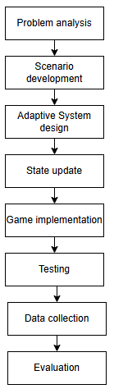
Fig 2. Research procedure
Stage 1: Problem and Requirements Analysis
The study identifies common school bullying situations and focuses on the role of bystanders. Based on this analysis, requirements related to scenario content, interaction, and assessment are defined.
Stage 2: Scenario Development and Behavioral Modeling
The scenarios are developed and designed in the form of a Visual Novel. Each scenario consists of a context, characters, triggering events, and a set of available choices [10].
Each choice is assigned one or more behavioral attributes. These attributes serve as inputs for the assessment system and adaptive logic.
Stage 3: Adaptive System Design
The system is designed based on the principle that the player’s behavior in the current scenario influences the scenario presented next.
After each choice, the system updates the player’s state. This state is then used to determine the difficulty level and type of the subsequent scenario.
Stage 4: Prototype Implementation
Based on the design developed in Stage 3, the research team implements the game as a Visual Novel. The system consists of a gameplay interface, dialogue system, choice system, adaptive logic controller, logging mechanism, and results screen.
Stage 5: Testing and Evaluation
At this stage, players experience a sequence of scenarios that are dynamically adjusted based on their previous choices. Behavioral data are collected throughout the gameplay process.
Upon completion, the system generates results report. The collected data are then used to evaluate the system’s functionality and analyze players’ behavioral tendencies.

Requirements Analysis and Scenario Design

Functional Requirements
The Bystander Choice game system is designed with the following core functionalities:
- Scenario Presentation: The system presents the context, characters, and progression of a bullying situation.
- Choice Selection: Players can select how to respond through available dialogue options or actions. The system determines the outcome of each choice and updates the player’s state accordingly.
- Scenario Adaptation: The system uses the current player state to select the subsequent scenario.
- Behavioral Data Logging: The system records data such as player choices, response time, scenario information, and outcomes.
- Assessment: After the player completes a sequence of scenarios, the system aggregates the collected data and generates an assessment result.

Non-Functional Requirements
In addition to the functional requirements, the game system is expected to satisfy the following non-functional requirements:
- A simple and student-friendly interface;
- Scenarios that are realistic while avoiding an unnecessarily threatening experience;
- Low system response latency;
- Structured storage of player data;
- Extensibility to support the addition of new scenarios;
- Content does not encourage violent behavior.
Assessment results should be presented from an educational and developmental perspective rather than as judgments of the player to encourage reflection and learning.

Adaptive Branching System and Adaptation Mechanism

Principle of Adaptive Branching
The key difference between Bystander Choice and conventional linear Visual Novel games is that the system does not follow a fixed sequence of scenarios for all players.
Instead:
$$Choice_{t}→PlayerState_{\left\{t+1\right\}}→Scenario_{\left\{t+1\right\}}$$
In other words, the player’s current choice affects their internal state, and this state subsequently influences the content of the next scenario [10].

Difficulty Adjustment Mechanism
The difficulty of subsequent scenarios can be divided into three levels:
- Basic: Situations are easy to recognize and involve limited social pressure;
- Intermediate: Situations contain multiple factors that make decision-making more challenging;
- Advanced: Situations involve peer pressure, potential interpersonal conflict, or multiple choices with subtle differences.
The system can reduce the difficulty level or provide additional guidance when necessary. This mechanism enables the system to create a more personalized learning pathway based on the player’s observed performance and behavioral patterns.

Technical Architecture and Dataflow of Adaptive Branching System
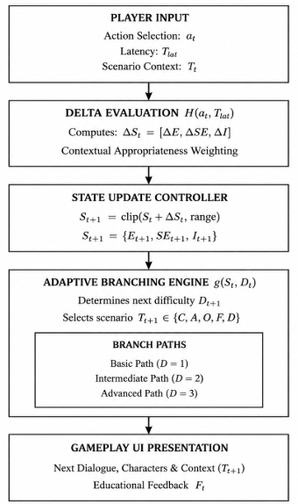
Fig 3. Detailed Technical Dataflow Architecture
The adaptive engine operates as a closed-loop controller consisting of three primary operational modules (Figure 3):
State Update Module ($H(a_{t}, T_{t})$): Evaluates player action $a_{t}$ within context $T_{t}$ and computes the indicator shift vector $ΔS_{t}$ = ${\left[ΔE, ΔSE, ΔI\right]}^{T}$.
State Register & Bounding Module: Updates cumulative state $S_{\left\{t+1\right\}}= clip\left(S_{t}+ΔS_{t}, \right)$ to maintain score normalized boundary constraints.
Branching Selection Function ($g\left(S_{t}, D_{t}\right)$): Maps current psychological indices $S_{t}$ and difficulty level $D_{t}$ to select subsequent scenario $T_{t+1}= \left\{C, A, O, F, D\right\}$.
Concrete Numerical Execution Example:
Initial State ($t=1$): Player starts at Intermediate level ($D_{1}= 2$) with initial baseline scores $S_{1}= \left\{E_{1}= 50, SE_{1}= 50, I_{1}= 50\right\}$.
Action Selection: In Scenario $T_{1}$ (Relational Bullying), the player chooses Direct Pro-social Intervention ($a_{1}$) after $T_{lat1}= 3.2s$.
Indicator Delta Computation: System assigns positive weights $ΔS_{1}= {\left[ΔE = +15, ΔSE = +20, ΔI = +25\right]}^{T}$ based on contextual risk.
New State: $S_{2}=\{E_{2}= 65, SE_{2}= 70, I_{2}= 75\}$.
Adaptive Selection: Since $SE_{2}≥ 70$ and $I_{2}≥70$, $g\left(S_{2}, D_{1}\right)$ elevates difficulty level to $D_{2}= 3$(Advanced Path), presenting a high peer-pressure Cyberbullying scenario ($T_{2}$) requiring nuanced conflict resolution.

Behavioral Assessment Model
In the Bystander Choice game system, player behavior is assessed using the three primary indicators introduced in Section 2.3. These three indicators are updated based on the player’s choices in each scenario, thereby forming a behavioral profile throughout the gameplay experience.
These indicators are not intended to serve as independent clinical psychological measurements. Instead, they are treated as representative behavioral indicators inferred from the player’s interactive behavior within the game environment [3].
The player’s state at time $t$ is represented as:
$$S_{t}= \left[E_{t}, SE_{t}, I_{t}\right]$$
where:
- $E_{t}$: represents the player’s empathy at time $t$
- $SE_{t}$: represents the player’s self-efficacy at time $t$
- $I_{t}$: represents the player’s intervention tendency at time $t$
After each choice, the system updates the player’s state according to:
$S_{\left\{t+1\right\}}=S_{t}+ΔS_{t}$ where $ΔS_{t}=\left[ΔE_{t},ΔSE_{t},ΔI_{t}\right]$
The value of $ΔE_{t}$, $ΔSE_{t}$ and $ΔI_{t}$ depend on the type of scenario, the player’s selected response, and the appropriateness of that response within the given context.

Update Indicators After Each Choice
After each decision, the system determines the changes in the three behavioral indicators.
Suppose that the player selects action $a_{t}$ in scenario $T_{t}$. The system first calculates:
$$ΔS_{t} =[ΔE\left(a_{t},T_{t}\right),ΔSE\left(a_{t},T_{t}\right),ΔI\left(a_{t},T_{t}\right)]$$
The indicators are then updated as follows:
$$E_{\left\{t+1\right\}}=clip\left(E_{t}+ΔE_{t},range\right)$$
$${SE}_{\left\{t+1\right\}}=clip\left(SE_{t}+Δ{SE}_{t},range\right)$$
$$I_{\left\{t+1\right\}}=clip\left(I_{t}+ΔI_{t},range\right)$$
The clip function ensures that the value of each indicator remains within the predefined range specified in the system design. This prevents the accumulated scores from exceeding the allowable bounds during repeated interactions.

Normalization and Result Classification
After the player completes the entire sequence of scenarios, the three indicators are normalized to a 0–100 scale:
$Score_{X}=100× X$ where $X∈\left\{E,SE,I\right\}$
The resulting scores can then be classified into three levels:
Table 2: Result Classification
Score Range | Assessment Level
0–39 | Low
40–69 | Medium
70–100 | High
This approach enables the system to generate a general behavioral profile of the player rather than reducing the assessment to a single overall score. Such a profile provides a more detailed representation of the player’s observed response patterns across different bullying scenarios.

The Indicators in Adaptive Logic
The indicators are not only used to generate the final assessment report but also serve as inputs to the adaptive mechanism.
The player’s state is represented as:
$$S_{t}=\left[E_{t},SE_{t},I_{t}\right]$$
The adaptive system uses this state to select the subsequent scenario:
$$T_{\left\{t+1\right\}}=g\left(E_{t},SE_{t},I_{t},D_{t}\right)$$
where $D_{t}$ represents the current difficulty level.

Ethics Statement

Ethics Statement and Consent Process
This study was conducted in accordance with the ethical standards of the institutional research committee (Approval Code: IRB-2026-N08). Prior to participation, written informed consent was obtained from the school administration and parents/legal guardians of all participants. Student assent was secured individually before session commencement, with explicit notification of their right to withdraw at any time without penalty.

Randomization and Participant Flow
Participants (N = 60, aged 15–17 years, 52% female, 48% male) were recruited from a local secondary school. Students were allocated into two equal arms ($n_{1}$ = $n_{2}$ = 30) using block randomization (1:1 ratio) via a computer-generated sequence. No participants dropped out during the 10-minute trial session.

Power Analysis and Multiple Testing Correction
An a priori power analysis was conducted using GPower (v3.1.9.7). Assuming a medium-to-large effect size (f = 0.38), an alpha level of $α$ = 0.05, and power (1 - $β$ = 0.80), a minimum sample size of N = 54 was required for a two-group pre-post design.
The final sample of N = 60 (n = 30 per group) provided sufficient statistical power. To control Type I, error inflation across the three primary psychological outcomes (BES, EI, BII), a Holm-Bonferroni correction was applied to all primary statistical tests, setting the initial adjusted significance threshold at $α_{adj}$ = 0.0167 (0.05 / 3)

Psychometric Reliability (Cronbach's $α$)
The internal consistency of all psychological measurement instruments was evaluated using the current study sample (N = 60). The 5-item Bystander Efficacy Score (BES) demonstrated strong internal reliability ($α= 0.86$), and the 5-item Empathy Index (EI) achieved $α= 0.83$. Additionally, the 3-scenario standardized Vignette Test measuring Bystander Intervention Intent (BII, score range 0–9) demonstrated acceptable internal consistency across scenarios ($α= 0.81$), confirming adequate psychometric reliability across all three primary evaluation dimensions.

System Architecture

Choice Bystander Choice Game Design

Interaction Model
The player is placed in a school environment and follows the progression of the story through visual elements, dialogue, and events. At designated decision points, the player is presented with several possible response options. After each decision, the system determines the corresponding outcome and proceeds to the subsequent content.

Scenario Structure
Each scenario is represented by a structure consisting of:
$$T=\{C,A,O,F,D\}$$
where:
- C (Context): the contextual setting of the scenario;
- A (Available Actions): the response options available to the player;
- (Outcome): the outcome resulting from the selected action;
- F (Feedback): feedback provided to the player after the decision;
- D (Difficulty): the difficulty level of the scenario.
Each available action is associated with a corresponding outcome and a set of behavioral attributes.

Data Flow
The gameplay process is designed as a sequence of the following steps:
Step 1 - Context Introduction: The player is introduced to a school environment and becomes familiar with the characters involved.
Step 2 - Scenario Presentation: An event containing potential signs of bullying occurs.
Step 3 - Problem Identification: The player observes the dialogue and events to identify the situation and the underlying problem.
Step 4 - Decision Making: The system presents a set of possible response options, allowing the player to select an appropriate course of action.
Step 5 - Feedback: The system presents the outcome of the selected action and its effects on the situation.
Step 6 - State Update: The behavioral and psychological indicators are updated based on the player’s choice.
Step 7 - Transition to the Next Scenario: After a decision point is completed, the system updates the player’s state and applies the Adaptive Logic to determine the content of the subsequent scenario.

Behavior Classification System
Player choices are classified into three primary behavioral categories:
- Passive Response: The player takes no action or chooses to avoid becoming involved in the situation.
- Indirect Intervention: The player seeks assistance or supports the victim without directly confronting the perpetrator.
- Direct Intervention: The player actively responds to and attempts to influence the situation.
This classification does not imply that direct intervention is always the optimal choice. In situations involving a high level of danger, seeking assistance from a teacher or another trusted adult may represent a safer and more appropriate response. Therefore, the system evaluates each choice based on its contextual appropriateness, rather than simply treating direct intervention as the correct answer.

User Interface Design

Start Screen
The start screen is the initial interface of the game and provides introductory information and basic functions, such as starting the game, viewing instructions, and configuring system settings. When the player starts a session, the system initializes the gameplay session and loads the first scenario.

Interactive Gameplay Interface
The gameplay interface consists of the scenario background, characters, dialogue, and available response options. The player assumes the role of a bystander and makes decisions when witnessing school bullying situations. Each choice is recorded together with the player’s response time and is used to update the three indicators: Empathy, Self-efficacy, and Intervention.

Assessment Results Interface
After completing a gameplay session, the system displays an assessment based on the defined behavioral and psychological indicators. The results also present the player’s behavioral tendency, categorized as Passive Response, Indirect Intervention, or Direct Intervention. In addition to quantitative results, the system provides educational feedback and recommendations to help players identify their strengths and areas for improvement in responding to bullying situations.

Data Analysis Dashboard
The dashboard enables monitoring of the player’s behavioral indicators and other relevant gameplay data. It also supports observation of the system’s adaptation process through the history of scenarios presented and the player’s responses. This information provides a basis for analyzing player behavior and evaluating the effectiveness of the adaptive mechanism implemented in Bystander Choice.

Evaluation benchmark and experimental results

Experimental Setup and Evaluation Metrics
The complete process of participant screening, block randomization, group allocation, and trial completion is illustrated in the CONSORT flow diagram (Figure 4).
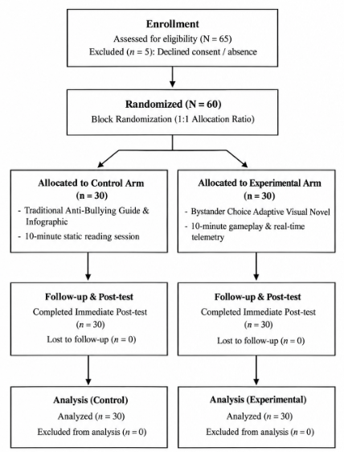
Fig 4. CONSORT Flow Diagram of Participant
To evaluate the effectiveness of the Bystander Choice adaptive game system in comparison with traditional educational materials, a Randomized Controlled Trial (RCT) was conducted with N = 60 high school students. Participants were randomly allocated into two equal groups:
- Control Group (n₁ = 30): Received a traditional 10-minute educational session reading an anti-bullying information guide and infographic.
- Experimental Group (n₂ = 30): Engaged in a 10-minute interactive session with the Bystander Choice adaptive visual novel while real-time telemetry logs were captured.
The benchmark evaluation framework comprises three core metric dimensions:
- Psychometric Indicators: Measured pre- and post-intervention using a 5-point Likert scale for Bystander Efficacy Score (BES) (5 items) and Empathy Index (EI) (5 items), alongside a standardized Vignette Test measuring Bystander Intervention Intent (BII) (3 real-world scenarios, score range 0–9).
- In-Game Telemetry Metrics: Real-time data captured from player choices, including Action Score S_{act} (0–15 points), Decision Latency (T_{lat}) (measured in seconds per scenario), and Adaptive Path Level (APL).
- System Acceptability: Measured post-intervention for the Experimental group using the standard System Usability Scale (SUS) (0–100 score).

Statistical Benchmark Results (Pre-test vs. Post-test)
Baseline measurements confirmed no statistically significant differences between the Control and Experimental groups prior to intervention (p > 0.05 across all metrics). Following the 10-minute intervention, both groups were re-assessed
Table 3: Descriptive Statistics and Mean Gains Across Groups (N = 60)
Metric Dimension | Group | Pre-test (M $±$ SD) | Post-test (M $±$SD) | Mean Gain ($Δ$)
Bystander Efficacy (BES)  (Range: 1.0–5.0) | Control (n=30) | 2.84 $±$ 0.62 | 3.05 ± 0.58 | +0.21
Bystander Efficacy (BES)  (Range: 1.0–5.0) | Experimental (n=30) | 2.81 $±$0.65 | 4.18 ± 0.48 | +1.37
Empathy Index (EI)  (Range: 1.0–5.0) | Control (n=30) | 3.12 ± 0.58 | 3.25 ± 0.52 | +0.13
Empathy Index (EI)  (Range: 1.0–5.0) | Experimental (n=30) | 3.15 ± 0.54 | 4.22 ± 0.45 | +1.07
Intervention Intent (BII)  (Range: 0–9) | Control (n=30) | 4.10 ± 1.45 | 4.85 ± 1.38 | +0.75
Intervention Intent (BII)  (Range: 0–9) | Experimental (n=30) | 4.05 ± 1.50 | 7.60 ± 1.10 | +3.55
Table 4: Statistical Verification and Effect Size Analysis
Metric Dimension | Bystander Efficacy (BES) | Empathy Index (EI) | Intervention Intent (BII)
Within-Group Control ($t_{control}(29)$) | $t\left(29\right)$= 2.14  $p$ = 0.041 | $t\left(29\right)$= 1.82  $p$ = 0.079 | $t\left(29\right)$= 2.85  $p$= 0.008
Within-Group Exp. ($t_{exp}(29)$) | $t\left(29\right)$= 9.85  $p$ < 0.001 | $t\left(29\right)$= 8.52  $p$ < 0.001 | $t\left(29\right)$= 10.62  $p$ < 0.001
Between-Group Gain Test ($t$) | $t(58)$ =7.42 | $t(58)$ = 6.88 | $t(58)$ = 8.15
Effect Size (Cohen's d [95% CI]) | 2.40  [1.72, 3.08] (Large) | 2.15  [1.50, 2.80] (Large) | 2.69  [1.98, 3.40] (Large)
$p$-value (Adjusted) | $p$ < 0.001 | $p$ < 0.001 | $p$ < 0.001
An Independent Samples $t$-test conducted on the gain scores ($Δ$_{Experimental} vs. $Δ$_{Control}) confirmed that the adaptive game intervention yielded statistically superior improvements over traditional materials across all three psychological indicators:
- BES Gain: $t$(58) = 7.42, $p$ < 0.001
- EI Gain: $t$(58) = 6.88, $p$ < 0.001
- BII Gain: $t$(58) = 8.15, $p$ < 0.001
All measured effect sizes (Cohen's d) in the Experimental group exceeded the target threshold of d $≥$ 0.8, indicating a substantial real-world impact
As highlighted in Table 4, the observed effect sizes in this study ($d$ > 2.0) are substantially higher than those reported in comparable serious game interventions (e.g., d = 0.32 - 0.78). While this large gain reflects strong short-term engagement, several methodological conflating factors must be acknowledged when interpreting these results:
- Novelty Effect: Participants experienced an interactive Visual Novel for the first time in a classroom setting, which likely amplified short-term motivation and post-test responsiveness compared to traditional static materials.
- Demand Characteristics: Because post-intervention testing occurred immediately after the 10-minute gameplay session, participants could readily infer the educational objective of the study, potentially inclining their responses toward perceived pro-social expectations.
- Hawthorne Effect: Awareness of participating in an active trial with real-time telemetry tracking may have temporarily heightened attention and decision reflection.
- Consequently, these values represent immediate post-intervention gain scores rather than stable, longitudinal behavioral changes. Future research must incorporate delayed follow-up post-tests (e.g., 1-month and 3-month post-intervention) to measure true retention and decay rates.
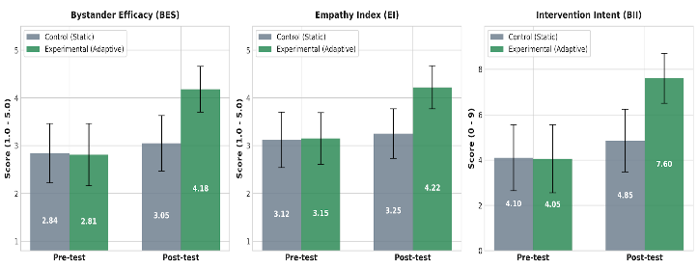
Fig 5. Pre-test vs. Post-test Psychological Outcomes Across Study Groups (N = 60)
To complement the quantitative tables, the intervention gains and behavioral adaptation dynamics were visualized across key metrics. As illustrated in Figure 5, the Experimental group exhibited substantial mean gains from pre- to post-test across all three dimensions, whereas the Control group showed minimal baseline drift.
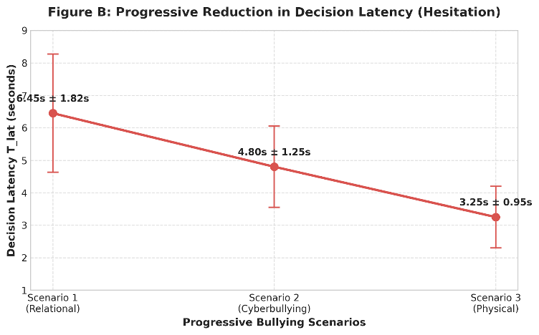
Fig 6. Progressive Reduction in Decision Latency
Furthermore, telemetry analysis (Figure 6) confirmed a progressive decline in decision latency (T_{lat1} = 6.45s $→$ T_{lat3} = 3.25s), indicating enhanced decision confidence.
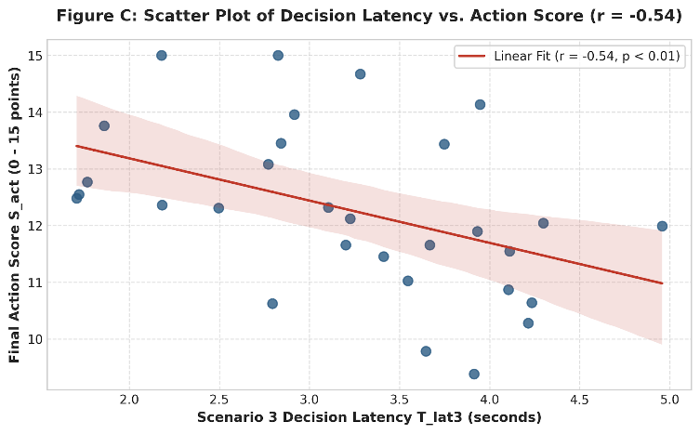
Fig 7. Scatter Plot of Decision Latency vs. Action Score
A scatter plot with a fitted regression line (Figure 7) highlights the significant inverse relationship between decision hesitation and action scores (r = -0.54, p < 0.01).
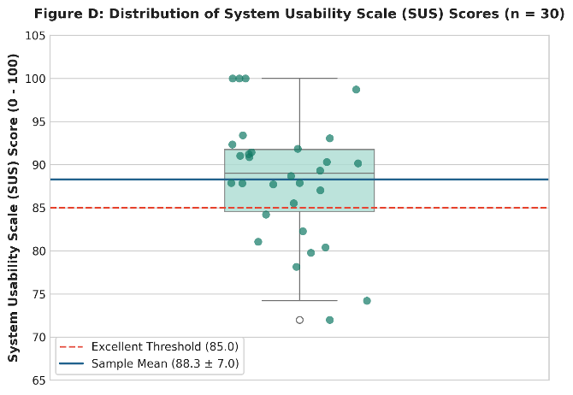
Fig 8. Distribution of System Usability Scale Scores
Finally, usability feedback (Figure 8) confirmed superior acceptability, with scores clustering tightly above the excellent threshold (M = 86.5, SD = 7.2).

In-Game Telemetry & Behavioral Adaptation Analysis
Telemetry data exported during gameplay provided continuous insights into player decision-making dynamics.
Decision Latency (T_{lat}) & Hesitation Reduction: Across the three progressive game scenarios, average decision latency decreased significantly while overall Action Scores (S_{act}) increased:
Scenario 1 (Relational Bullying): T_{lat1} = 6.45 $±$ 1.82s
Scenario 2 (Cyberbullying): T_{lat2}= 4.80 $±$ 1.25s
Scenario 3 (Physical Bullying): T_{lat3} = 3.25 $±$ 0.95s
A negative Pearson correlation was observed between Scenario 3 decision latency T_{lat3} and the final Action Score S_{act} (r = -0.54, p < 0.01), suggesting that repeated interaction within the simulated environment effectively reduced psychological hesitation when choosing pro-social bystander actions.
Along with response latency, players' overall Action Scores (S_{act}, scale 0–15) increased from Scenario 1 (M = 8.2, SD = 2.1) to Scenario 3 (M = 12.6, SD = 1.8). Regarding Adaptive Path Levels (APL), 63.3% of participants (n = 19) progressed to the Advanced difficulty path, 26.7% (n = 8) remained at Intermediate, and 10.0% (n = 3) were maintained at Basic level with supplementary guidance.

System Usability Scale (SUS) Evaluation
Post-test usability evaluation from the Experimental group yielded an average SUS score of 86.5 $±$ 7.2 out of 100. According to standard SUS benchmarks, a score $≥$ 85 categorizes the software usability as "Excellent", confirming high user satisfaction, interface clarity, and overall system learnability and ease of use during gameplay.

Conclusion

Results achieved
This study designed and developed Bystander Choice, an adaptive game system aimed at simulating school bullying situations and supporting students in developing situational response skills from the perspective of a bystander.
The system implements an interactive mechanism based on player choices and records behavioral data throughout the gameplay experience. Based on these choices, the system estimates behavioral and psychological indicators and simultaneously uses the player’s current state to adapt the content of subsequent scenarios through the adaptive mechanism.
In addition, the study implemented an assessment results interface to provide personalized feedback and a dashboard for data visualization, supporting the monitoring of behavioral tendencies and analysis of gameplay results.
The initial results indicate that the proposed adaptive game model has the potential to integrate scenario-based simulation, behavioral assessment, personalized experiences, and behavioral data collection. This provides a foundation for further research into game-based intervention approaches in educational environments.

Limitations
Despite the results achieved, the study has several limitations.
First, the scale and scope of the evaluation were limited; therefore, the findings are not yet sufficient to be generalized to the broader student population.
Second, the indicators are inferred from players’ behaviors and choices within the game and therefore cannot fully replace established and standardized psychometric measures.
Third, the control group received static paper-based materials rather than non-adaptive linear games. Consequently, while the findings confirm the overall intervention efficacy of Bystander Choice over traditional tools, they do not completely isolate the specific added value of the adaptive mechanism from general game engagement.
Finally, the study primarily evaluates player behavior within a simulated environment. Consequently, the extent to which the observed behavioral patterns transfer to real-world school bullying situations remains to be investigated.

Future Work
Future research could increase the number of participants and conduct experiments with different participant groups to improve the reliability and generalizability of the findings.
Regarding the adaptive mechanism, future studies could further develop the adaptation logic to make it more automated and flexible, enabling the system to select subsequent content based on each player’s behavioral history and accumulated interaction patterns.
Further validation using standardized psychological scales and real-world or longitudinal evaluations would also be valuable for examining the relationship between in-game behavioral indicators and actual bystander responses in school bullying situations.
Future evaluations will implement a three-arm randomized design (Control vs. Linear Non-Adaptive Game vs. Adaptive Game) to explicitly isolate and measure the specific therapeutic and educational contribution of real-time personalized adaptation.

Appendix
Game Screen Interface


Fig 9. Main Screen

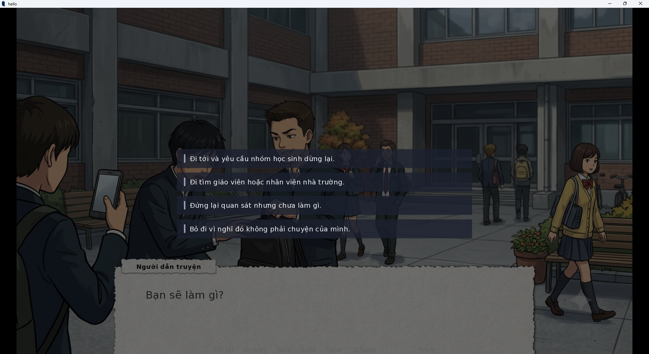
Fig 10. Selection Screen
This is the primary interactive interface, simulating a school violence scenario in the style of a visual novel. Players follow the setting, characters, and dialogue, then select a course of action. The system records each choice to update the status and facilitate behavioral assessment.

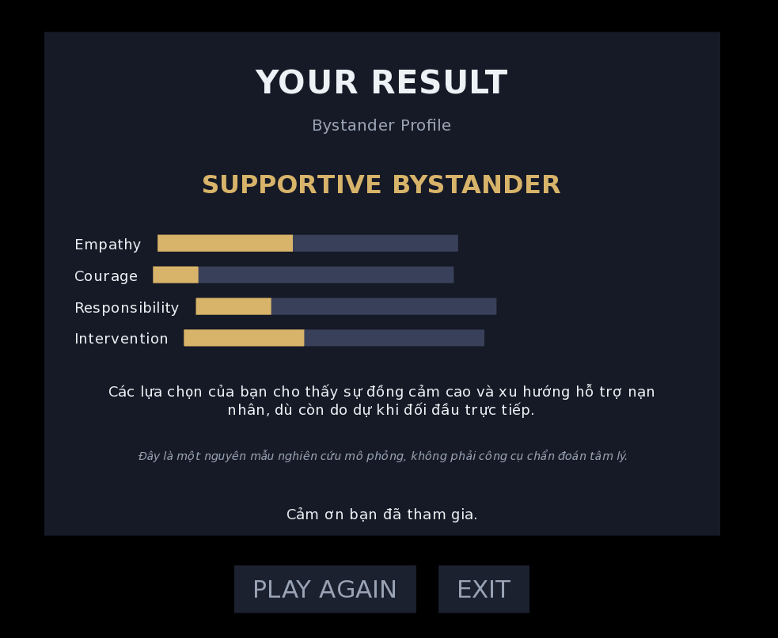
Fig 11. Result of The Player
Upon completion of the game, the system displays the player's profile (Bystander Profile), assessment metrics, and a general overview of behavioral tendencies. The screen also provides educational feedback and notes that the results are for research purposes only and do not constitute a psychological diagnostic tool.
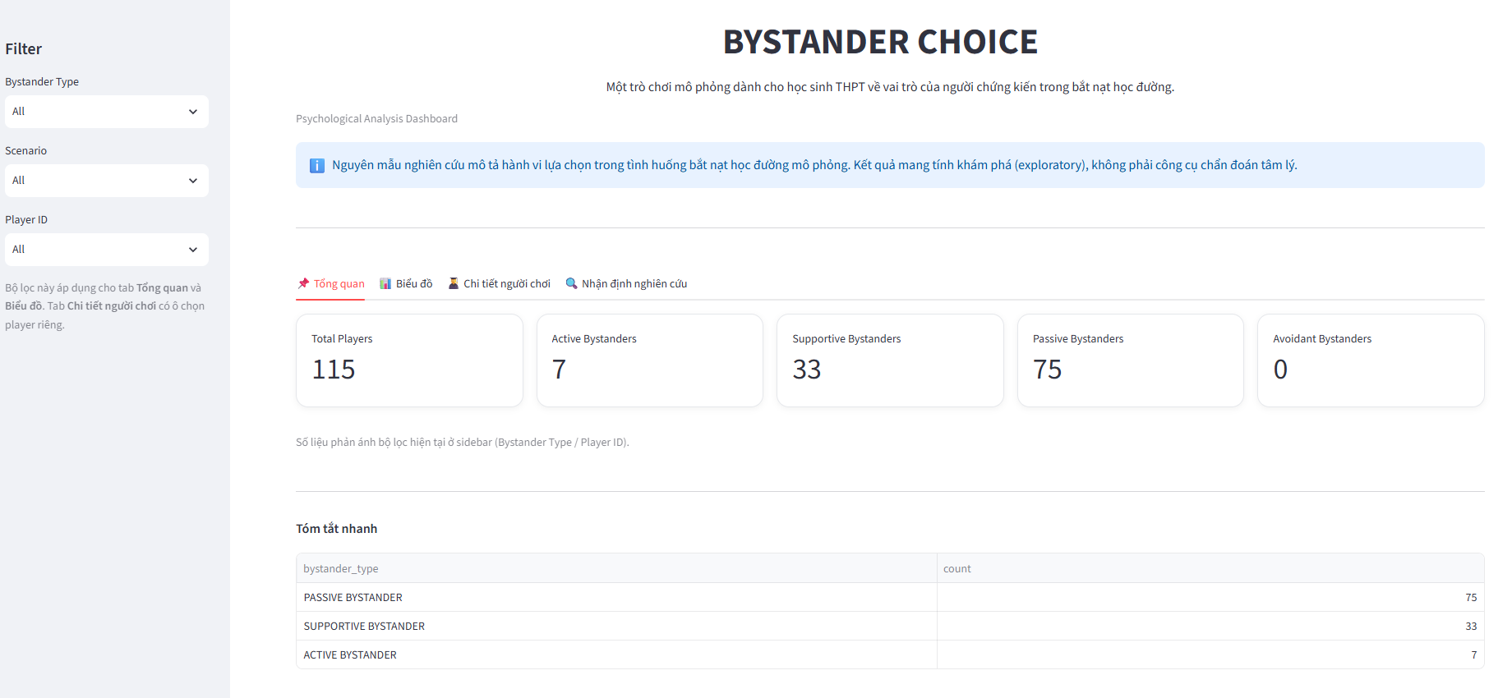
Fig 12. Data Overview Screen
The Overview screen provides a comprehensive view of participant data and the results of bystander behavior classification in school bullying situations.
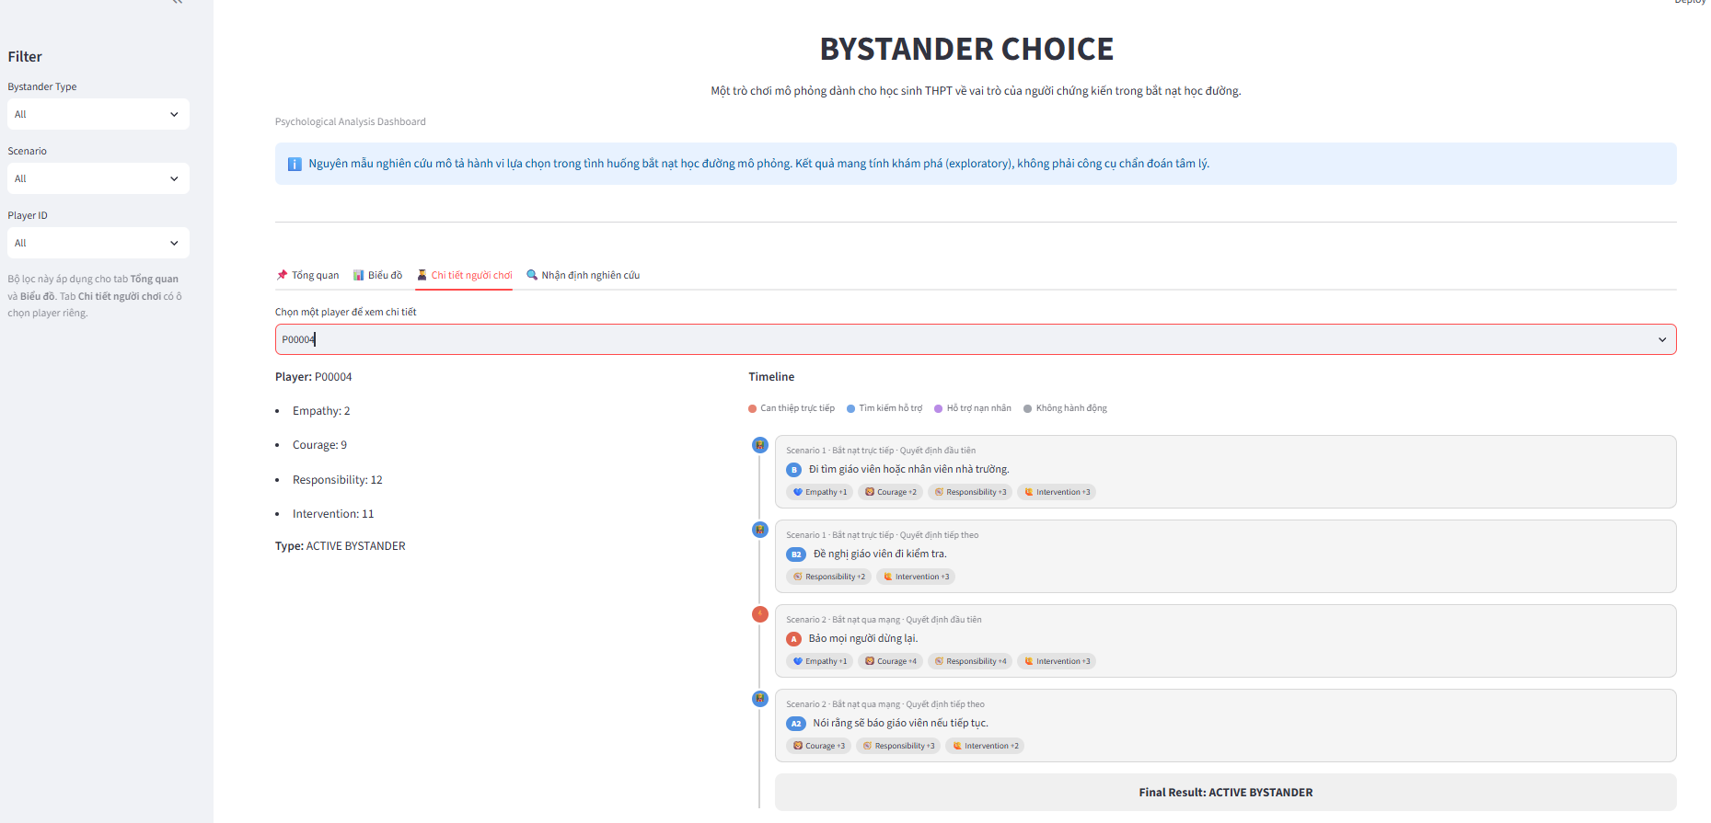
Fig 13. The Player Details Screen
The Player Details screen allows for the selection of a specific participant to conduct an in-depth analysis of their decision-making process. The system displays relevant metrics while presenting a timeline of the decisions made by the player across each scenario. Based on the sequence of choices, the system determines and displays the player's final classification result.

References

[1] | Salmivalli, C., Lagerspetz, K., Björkqvist, K., Österman, K., & Kaukiainen, A., "Bullying as a group process: Participant roles and their relations to social status within the group. Aggressive Behavior, 22(1), 1–15.," 1996.
[2] | DeSmet, A., Van Cleemput, K., Bastiaensens, S., Poels, K., Vandebosch, H., Malliet, S., Verloigne, M., Vanwolleghem, G., Mertens, L., Cardon, G., & De Bourdeaudhuij, I. , "Bridging behavior science and gaming theory: Using the Intervention Mapping Protocol to design a serious game against cyberbullying. Computers in Human Behavior, 56, 337–351.," 2016.
[3] | DeSmet, A., Bastiaensens, S., Van Cleemput, K., Poels, K., Vandebosch, H., Deboutte, G., Herrewijn, L., Malliet, S., Pabian, S., Van Broeckhoven, F., De Troyer, O., Deglorie, F., Van Hoecke, S., Samyn, K., & De Bourdeaudhuij, I. , "The efficacy of the Friendly Attac serious digital game to promote prosocial bystander behavior in cyberbullying among young adolescents: A cluster-randomized controlled trial. Computers in Human Behavior, 78, 336–347.," 2018.
[4] | Kolić-Vehovec, S., Smojver-Ažić, S., Martinac Dorčić, T., & Rončević Zubković, B., "Evaluation of serious game for changing students' behaviour in bullying situation. Journal of Computer Assisted Learning, 36(3), 323–334.," 2020.
[5] | Fredrick, S. S., Jenkins, L. N., & Ray, K. , "Dimensions of empathy and bystander intervention in bullying in elementary school. Journal of School Psychology, 79, 31–42.," 2020.
[6] | Clark, M., & Bussey, K. , "The role of self-efficacy in defending cyberbullying victims. Computers in Human Behavior, 109, 106340.," 2020.
[7] | Deng, X., Yang, J., & Wu, Y. , "Adolescent empathy influences bystander defending in school bullying: A three-level meta-analysis. Frontiers in Psychology, 12, 690898.," 2021.
[8] | Hu, Y., Zhang, T., Shi, H.-F., & Fan, C.-Y., "Empathy and bystander helping behavior in cyberbullying among adolescents: The mediating role of internet moral judgment and the moderating role of internet self-efficacy. Frontiers in Psychology, 14, 1196571.," 2023.
[9] | Willems, R. A., Sapouna, M., De Amicis, L., Völlink, T., Dehue, F., Dimakos, I., Priovolou, K., Nikolaou, G., & Rosinský, R. , "Encouraging positive bystander responses to bias-based bullying in primary schools through a serious game approach: A non-randomized controlled evaluation of the GATE-BULL program. International Journal of Bullying Prevention, 7, 566–580.," 2025.
[10] | İsa Özgür Özer, Mehmet Bilgin, "Designing and evaluating an interactive visual novel to increase bullying bystander intervention in schools: A four-wave controlled time-series study.," Journal of Research on Technology in Education, 2026.

